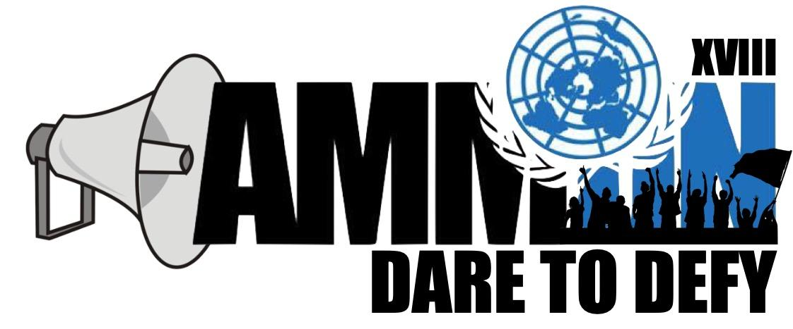

Forum: International Court of Justice
Issue: Criminal Proceedings in France (Republic of Congo v. France)
Student Officers: Zein Al Hmoud and Yasmin Oumeish
Position: President and Deputy President

- Introduction

Numerous allegations of grave violations of human rights in the Democratic Republic of the Congo were received since the start of 1998. The Rapporteur on the situation of human rights in the Democratic Republic of the Congo expressed deep concern about the continuing deterioration of human rights in the country and called on the Government of President to take all necessary measures to rectify the situation. A complaint was filed a few years later on the 5th of December 2001 on behalf of several human rights organizations for crimes against humanity and torture, allegedly committed by members of Congo’s government against the Congolese people by France. The complaints were filed against the President of the Republic of the Congo, Mr. Denis Sassou Nguesso, the Congolese Minister of the Interior, General Pierre Oba, and a few other individuals. However, Congo claims that it is their country’s duty to prosecute those responsible for these allegations as well as the fact that France should not intervene in their internal affairs. So, on the 23rd of January 2002, an investigation was initiated. The Republic of Congo argued that France violated the principle that a State may not, in breach of the principle of sovereign equality among all Members of the United Nations, exercise its authority on the territory of another State as well as violate the criminal immunity of a foreign head of state. On the other hand, France argues that it was their responsibility to interfere and protect the Congolese people based on the virtue of erga omnes, as well as the virtue of a principle of international customary law providing for universal jurisdiction over crimes such as these, some articles from the French Code of Criminal Procedure.

- Definition of Key Terms

International Court of Justice (ICJ)
The ICJ is the main judicial organ of the United Nations, established on the 26th of June, 1945 in San Francisco, USA. It is in charge of settling legal disputes submitted by states in accordance with international law.
Erga Omnes
A legal latin term directly translating to “towards all” or “towards everyone”. When used legally, it means rights or obligations are owed towards all. In this case, France could have been fulfilling its responsibility towards the Congolese population in filing a complaint against the leaders.
Crimes Against Humanity
Deliberate acts, usually part of a widespread or systematic attack, causing human suffering or death on a large scale. Some acts that classify as Crimes Against Humanity are murder, extermination, displacement, torture, sexual violence, and death against civilians.
Jurisdiction
The official power to make legal decisions and judgements. In this case, it is the authority given by law to a court to try cases and rule on legal matters within a particular geographic area and/or over certain types of legal cases.
Prima Facie
A legal latin term directly translating to “at first sight”. In this case, it is defined as accepted as correct until proved otherwise. A prima facie basis of jurisdiction was requested in order for provisional measures to be indicated.
Ad hoc
A legal latin term directly translating to “for that purpose”. In court, it is used to refer to a judge appointed for a particular purpose.
Sovereignty
The authority of a state to govern itself or another state. In this situation, it was argued that France violated the Republic of Congo’s sovereignty by interfering in their internal matters.
ICJ Statute
The ICJ Statute is an extremely prevalent section of the UN Charter. As mentioned in Chapter 14 of the UN Charter, which was also used to establish the ICJ. The Statue’s purpose is to see if a crime is applicable to a certain article or chapter and grants each case jurisdiction accordingly. It emphasizes on the rules of the court, and all of its rules of procedure.
- General Overview – Background information
Factual Background
- Complaint filed by France on 5 December 2001 for crimes against humanity and torture allegedly committed
- The Procureur de la Republique of the Paris Tribunal de grande instance transmitted that complaint to the Procureur de la Republique of the Meaux Tribunal de grande instance, who ordered a preliminary enquiry.
- 23 January 2002 application for a judicial investigation of the alleged offences (requisitoire) was issued, and the investigating judge of Meaux initiated an investigation
- The Meaux requested investigation of both crimes against humanity and torture, without mentioning any jurisdictional basis other than Article 689-1.
- The investigation was initiated against a non-identified person , not against any of the Congolese personalities named in the complaint.
- The testimony of General Dabira was first taken on 23 May 2002. on the 16th of september 2002 the investigating judge issued against him, who had by then returned to Congo, which, it was explained by France at the hearing, could be enforced against him should he return to France, but is not capable of being executed outside French territory.
- The Application states that when the President of the Republic of the Congo, H.E. Mr. Denis Sassou Nguesso “was on a State visit to France, the investigating judge issued a commission rogatoire (warrant) to judicial police officers instructing them to take testimony from him”. However no such warrant has been produced, and France has informed the Court that no warrant was issued against President Sassou Nguesso, but that the investigating judge sought to obtain evidence from him under Article 656 of the Code of Criminal Procedure, applicable where evidence is sought through the diplomatic channel from a - 3 - “representative of a foreign power”; the Congo acknowledged in its Application that President Sassou Nguesso was never “mis en examen, nor called as a témoin assisté”.

- Major Parties Involved and Their Views
The French Republic (France):
France is one of the two major parties involved in this case. France argues that it has jurisdiction to interfere in alleged affairs of crimes against humanity and torture by the Congolese government against the citizens within Congo, mainly based on the virtue of a principle of international customary law providing for universal jurisdiction over crimes such as these, on the basis of Articles 689-1 and 689-2 of the French Code of Criminal Procedure. France initially filed a complaint about these alleged crimes on behalf of many human rights organizations, later initiating investigations against a non-identified person within the Congolese Government.

The Republic of Congo (Congo):
Congo is the second major parties involved in this case. Congo argues that France has violated the principle of sovereign equality among all members of the UN, therefore attributing to itself universal jurisdiction in criminal matters. In addition, Congo argues that France is arrogating to itself the power to prosecute the minister of the interior of a foreign state for crimes allegedly committed in connection with the exercise of his power for the maintenance of public order in his country (meaning they are arguing that France is giving itself the power to interfere in the actions of a foreign head of state connected to maintaining public order in his country, prosecuting this leader for crimes allegedly committed).

- Congo Requests:
- Declare that the French Republic annulls the investigation and prosecution
- Indication of a provisional measure directed to the preservation to the right of the Congo under both of the categories
- Seeking an order for the immediate suspension of the proceedings being conducted by the investigating judge of the Meaux Tribunal de grande instance

- Timeline of Events

Date | Description of event
5 December 2001 | A complaint was filed on behalf of certain human rights organizations, with the Procureur de la République of the Paris Tribunal de grande instance for crimes against humanity and torture allegedly committed in the Congo
23 January 2002 | Issued a réquisitoire (application for a judicial investigation of the alleged offences), and the investigating judge of Meaux initiated an investigation
23 May 2002 | The testimony of General Dabira was first taken by judicial police officers who had taken him into custody

- UN Involvement, Relevant Resolutions, Treaties and Events:

France and Congo do not have a history of conflicts or disputes involving the UN. UN involvement began in 2002 when judicial investigations related to the Case of certain criminal proceedings in France were initiated.
Relevant Resolutions:
The first relevant resolution is the UN Charter, more specifically, paragraph one of Article 2. Congo sought to institute proceedings against France of the grounds of France’s alleged violation of this article.

Article 2
The Organization and its Members, in pursuit of the Purposes stated in Article 1, shall act in accordance with the following Principles.
- The Organization is based on the principle of the sovereign equality of all its Members.
The second relevant resolution is the French Code of Criminal Procedure, more specifically, Articles 689-1 and 689-2. France used these articles to argue that they had jurisdiction regarding crimes against humanity. As well as Article 656.
Article 656
The written statement of the representative of a foreign power is requested through the intermediary of the Minister for Foreign Affairs. If the application is granted, the statement is received by the president of the appeal court or by a judge delegated by him. Matters then proceed in the manner set out in articles 654, paragraph 2, and 655
Article 689-1
In accordance with the international Conventions quoted in the following articles, a person guilty of committing any of the offences listed by these provisions outside the territory of the Republic and who happens to be in France may be prosecuted and tried by French courts. The provisions of the present article apply to attempts to commit these offences, in every case where attempt is punishable.

Article 689-2
For the implementation of the Convention against Torture and other Cruel, Inhuman or Degrading Treatment or Punishment, adopted in New York on 10th December 1984, any person guilty of torture in the sense of article 1 of the Convention may be prosecuted and tried in accordance with the provisions of article 689-1.

Major Treaties and Events:
- Treaties:
There are no treaties between Congo and France that are relevant to this case.

- Events:

- Evaluation of Previous Attempts to Resolve the Issue

(State what previous attempts has been (what was the action plan of resolutions passed above))

- Possible Solutions
According to THIMUN rules of procedure in the International Court of Justice advocates and judges are obliged to not take the actual verdict into consideration therefore when coming up with their verdicts and solutions they must come up with them while keeping in mind that the issue was never solved.

(Come up with 2 of your own solutions to the problem and have them in paragraph format)

- Guiding Questions
- What was allegedly being committed in Congo by the Congolese Government?
- Do these acts classify as Crimes Against Humanity?
- Did France and Congo have a history of conflicts between them?
- Appendices and useful links

(list all appendices and links that you would like to redirect your delegates to in roman numerals)

- Contact Info

Notes:
- Ariel size 11
- Paragraphs begin with indentation
- Section headings must be in this color and bold in Arial font size 14
- Sub headings size 12 and this color
- The research report should be between 3,500 and 5000 words
- 0.5 line spacing
- Save as .docx format
- Every picture included in the report must contain captions, describe the picture or diagram in a (Arial size 9, bold and italicized)
- Same Border as one used on this document
- All text in blue should be in this color

